My Interview with Tamara Philip Author of
“The Trouble with Playing Cupid”


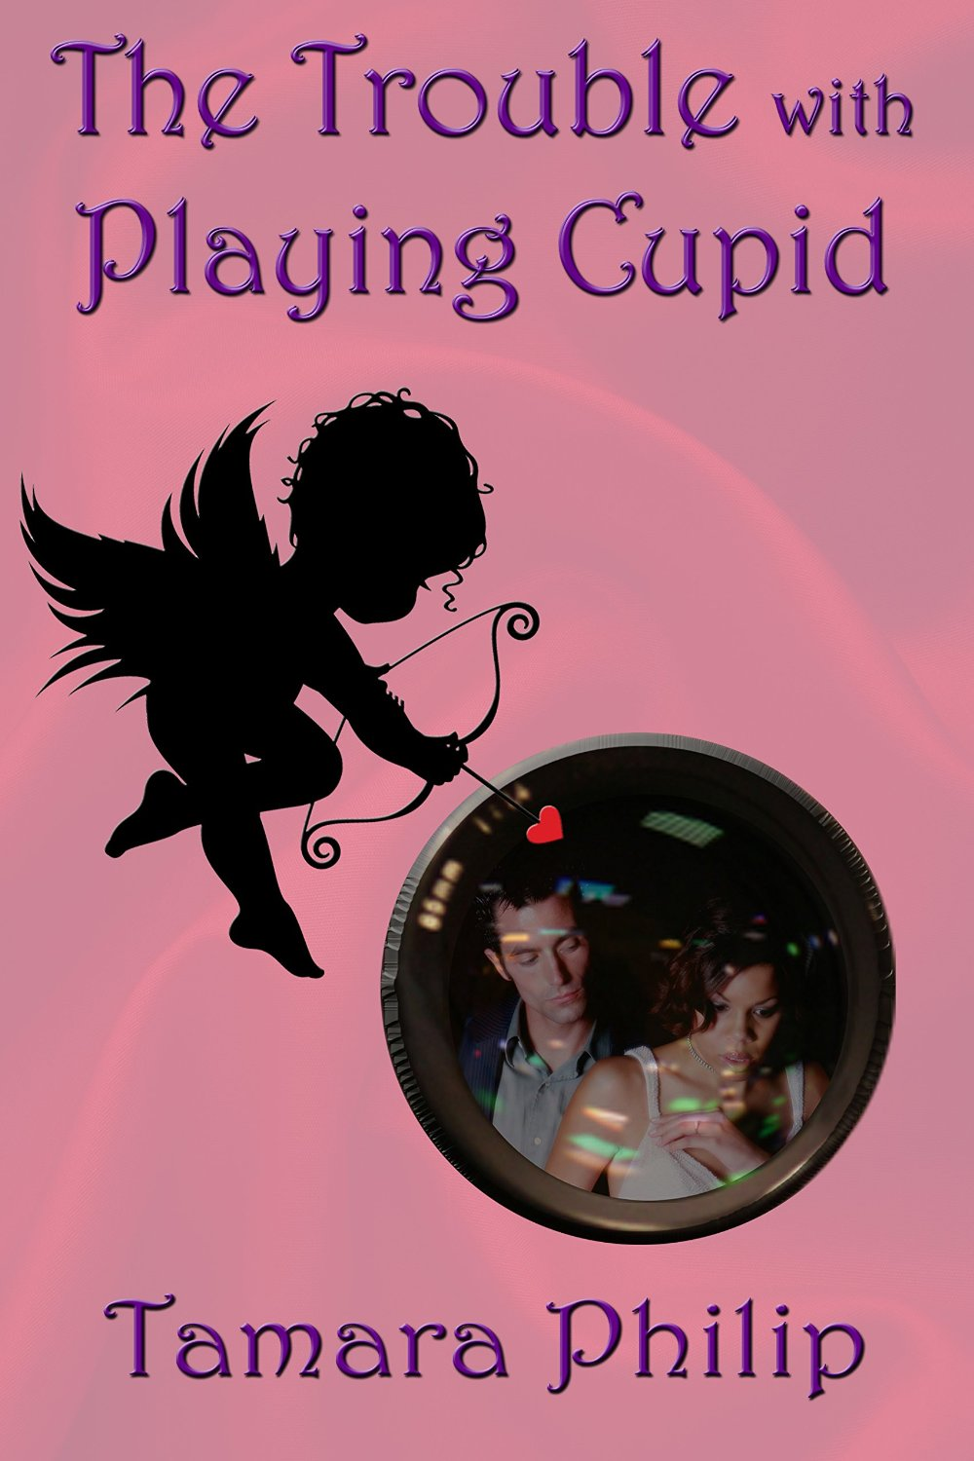

- Where do you currently reside?

I’ve lived in Trinidad and Tobago for the past 6 years.

- What is island life like?

It's hot! LOL The thoughtless yet random acts of kindness that people do for one another on a day to day basis keeps makes me feel proud to be a Trinidadian. Even though I grew up in NYC and still feel that is my hometown.

- Tell us about your current release, “The Trouble with Playing Cupid”?

It's an ill-timed matchmaking love story between two celebrities who didn't even realize they were missing something until they met each other.

- What inspired you to write “The Trouble with Playing Cupid?”

I'm a shameless day dreamer who refuses to keep that shame to herself. LOL

- What was the scariest moment of your life?

The day my father had his stroke. It was just a normal day and yet in one moment, in one phone call our lives haven't been the same since. There's no way you can remain unscarred or unchanged by something like that.

- What family members are closest to you and how have they supported your writing career?

My fiancé, parents and my 3 younger sisters. They're endless patience and general putting up with my horribleness. They're absolute stars!

- What was your favorite book series growing up?

There are so many but anything by Jerry Spinelli. Especially Maniac Magee. Absolute favorite book when I was a tween.

- What is the most disgusting thing that you have ever done in your life?
Yikes!! I've done a lot of gross things in my life, I don't even know where to start.

- What are the lyrics to a song that have stuck in your head and inspired you?

Brian McKnight’s song. Where he goes "stay or let it go" It’s not even my favorite song but those words always resonate in the back of my mind every day. Especially when I'm about to get upset at something. It's very weird.

- What website would you warn others to stay away from and why?
Pinterest. Just one click of a link and you're lost in it forever. Whole entire days, gone! Just like that! It's my favorite site!

Find Tamara’s book here, as well as at many other fine retailers:

http://www.amazon.com/Trouble-Playing-Cupid-Tamara-Philip-ebook/dp/B00M3DQIT4/ref=sr_1_1?ie=UTF8&qid=1409717438&sr=8-1&keywords=the+trouble+with+playing+cupid

http://www.barnesandnoble.com/w/the-trouble-with-playing-cupid-tamara-philip/1120022574?ean=2940045663649

https://www.allromanceebooks.com/product-thetroublewithplayingcupid-1578577-149.html

